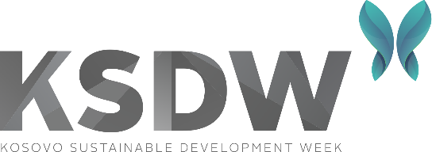
16 – 20 September 2024
Pristina, Kosovo

GREEN JOURNALISM COMPETITION

Are you a talented journalist with a passion for environmental issues? We invite you to enter our Green Journalism Competition!
Kosovo Sustainable Development Week (KSDW) is an annual event for sustainable development, which promotes a green economy, a stable social setting, and the protection of the environment in the Western Balkans region. For its 7th edition, KSDW has launched a competition focused on green journalism stories. This competition invites journalists from various backgrounds and regions in Kosovo to submit their best work on climate change, biodiversity, sustainable agriculture, and environmental sustainability topics. The competition aims to promote green journalism and encourage reporters to explore and uncover crucial environmental issues impacting our country. The submitted stories can be in various formats, such as written articles, audio or video reports, photo essays, and infographics. The entries will be judged based on the story's creativity, relevance, impact, and journalistic quality.
The competition is open until 7 September 2024, and winners will be announced on 20th of September, at the Closing Ceremony of Kosovo Sustainable Development Week. The top three entries will receive cash prizes of 400 EUR, 350 EUR, and 250 EUR respectively. In addition, the winning stories will be published on our website and shared on our social media platforms.

How to enter the competition?
To enter the competition, submit your story (written article, audio, video report, photo essay, and infographic) and a short author bio to gent.jakupi@indep.info by the 7 September at 23:59 hr.
We encourage all Kosovo journalists passionate about environmental issues to participate in this exciting competition and help raise awareness of the importance of green journalism. Let's join forces in making a positive impact on our environment!

*KSDW is jointly organized by the Committee on Agriculture, Forestry, Rural Development, Environment, Spatial Planning, and Infrastructure within the Assembly of the Republic of Kosovo, the Ministry of Environment, Spatial Planning and Infrastructure, the Ministry of Economy, the Municipality of Pristina, the Office of the EU Special Representative in Kosovo, Germany through GIZ Kosovo, Institute for Development Policy (INDEP), and Balkan Green Foundation (BGF) in Kosovo, aimed at advancing the public dialogue and promoting sustainable development.

